Hammertyme: The Philadelphia Blacksmiths Guild

August/September 2012, Volume 1 Issue 8,9
October/November Combined Issue
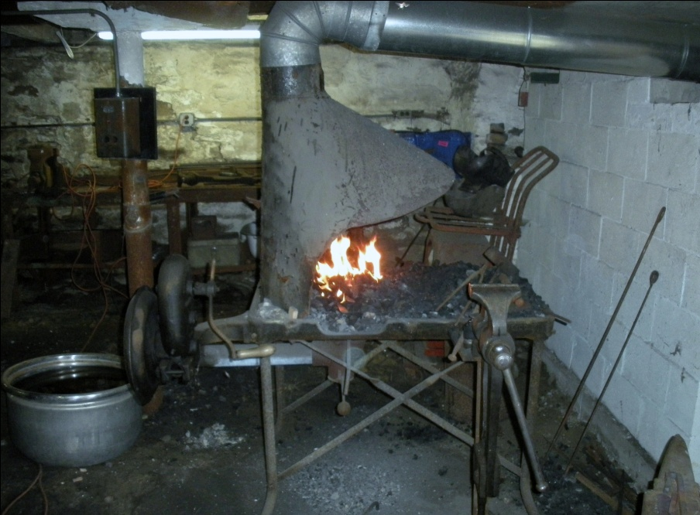
Meeting Postponed
Due to Hurricane Sandy, the Holcombe-Jimison Farm Museum is without power for the immediate future. As a result, we are postponing our November meeting to a date to be announced. Please bear with us while we endeavor to reschedule the event. Members will be notified of the new date in November, by telephone.
Group News

Thanks to Ben Suhaka and the people at the Holcomb-Jimison Farm Museum and Blacksmith Shop, we will have two meetings of our group in August. On Sunday, August 12, from 9AM-?, we will have our regular group meeting at the blacksmith shop, which is extremely participatory. Remember to bring work shoes and safety glasses, because you will be expected to participate in forging beautiful iron projects. Our meetings are open to neophytes to blacksmithing, as well as experienced smiths. Then exactly one week later, at the same venue, we will have our second monthly meeting in conjunction with the tool-swapping group that also meets at that location on Aug. 19. Farmers and tool swappers have been urged to bring blacksmithing tools to sell and swap to us, especially the newbies who lack the basic tools. Both meetings are located on NJ Route 29, in Lambertville, in close proximity to the police station there. Looking forward to both meetings!

September Meeting
We shall be meeting at the Holcombe-Jimison Farm Museum on Sunday, Sept. 23, from 10AM to 3PM. The meeting is located on NJ Route 29, right next door to the Lambertville Police Department. Make sure you bring safety glasses and work shoes, because our meetings are participatory.

August Meetings
Right before our first August Meeting at the Holcombe-Jimison Farm Museum, at the Lambertville NJ Flea Market, I discovered a vendor with a nice 150 lb. Mousehole Anvil for sale. I immediately ran to the meeting, and told one of our members about it, who purchased that anvil right away. Pictured below is Dave Boyer sporting his new anvil at the meeting!
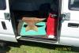
We proceeded to forge the rest of the latch which we commenced at the previous meeting, forging the thumb piece and back bar, in the same style as the latch. Then we punched the screw holes and the hole for the thumb piece in the handle itself. Pictured below is Ben Suhaka holding the latch proudly. The Guild donated the latch to the Holcombe-Jimison Farmstead, which has an original farmhouse from 1740.

Second August Meeting
During the second meeting in August, we recruited two new members to the group, including Bob and Matt, pictured below, along with the usual suspects at Holcombe-Jimison. We put the finishing touches on the door latch that we forged for the Museum. A wonderful time was had by all, emphasized by the smiling faces in the pictures below. Yes, our group is GROWING!
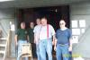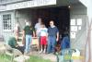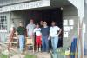

July Meeting

We met at the Holcomb Jimison Farm Museum, where our President, Stuart Geisler, gave a lecture and demonstration on how to forge a Colonial door latch taken from the pages of the classic book “Early American Wrought Iron” by Albert Sonn. This set of tomes is a compendium of early American wrought ironwork done in the 18th century, complete with hand drawn pictures of these beautiful pieces. Albert Sonn hand drew all these hundreds of latches and strap hinges in 1928, which was a considerable project! After forging the pictured latch, Guild member Robert Herrmann tried his hand at forging a latch in the afternoon, and did a wonderful job!

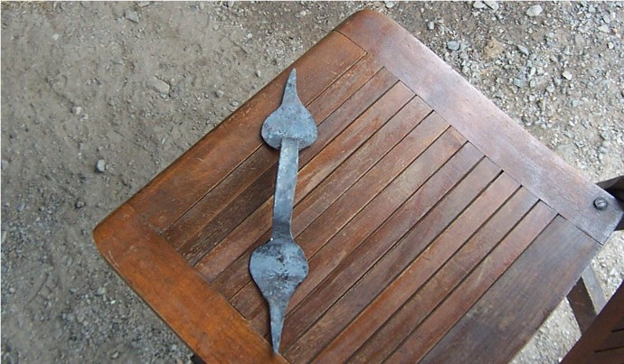

Pictured above is the latch that Stuart forged in the morning session. It is a copy of a latch on page 157 in Sonn’s treatise.
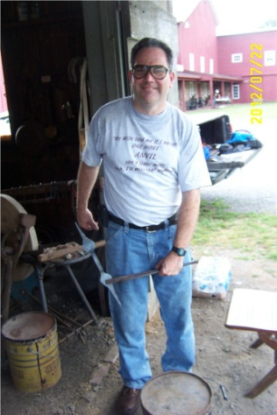
This is a picture of Robert holding the latch he forged in the afternoon in a pair of tongs. Bravo!
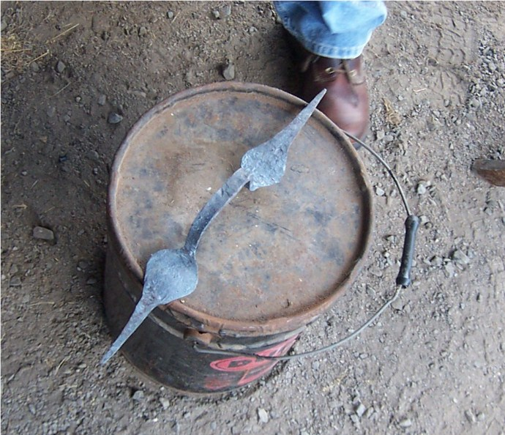
This next picture is a close-up of Bob’s latch! Very nice job of it, my friend!

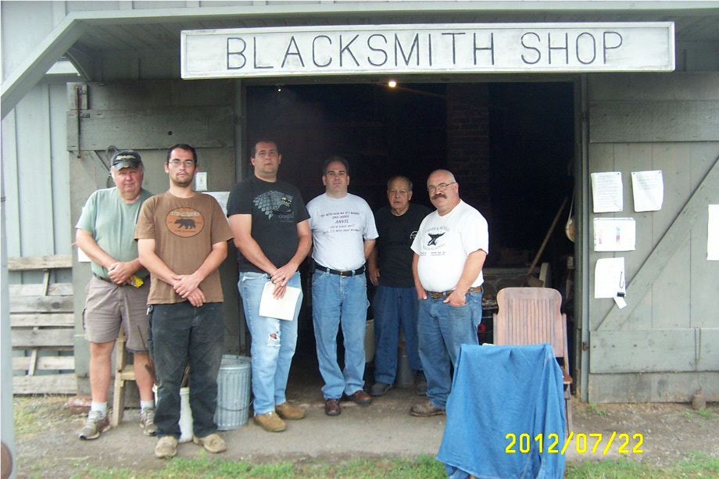
Finally, the last picture of our motley crew depicts, from left to right Josh Kavett, Ben Suhaka, Robert Herrmann, Andrew McMackin, Allan McMackin, and Josh’s friend Karl. Obviously, Stuart Geisler took the photo! Other participants came for the afternoon session, but alas, I was too lazy to take another picture!

More Club News
Josh Kavett, who attended our July Meeting, cordially invited our entire group to visit his Fisher Anvil Museum, which he curates. Josh has a complete collection, which is absolutely amazing, of every anvil ever manufactured by Fisher Eagle Anvil Works, in Trenton, NJ. He even owns a group of wooden patterns for casting these anvils, as well as the Patents for their manufacture. With over 350 anvils, Josh has devoted a lifetime to collecting and documenting these artifacts. Thank you, Josh. We will definitely have a meeting at your venue!

Forging Door Latches
In order to get the larger areas of a latch wide enough, especially forging leaves, one must start with enough material in order to get that part of the latch WIDE! That is why I start with either ¾ inch round rebar, or a metal strap that is at least inch and a half wide by quarter inch thick. Obviously, to forge a leaf, one must taper the end into a point. To get the wide part of the leaf wide enough, I cross pein the flat area on both sides, getting it wider and wider. I do this at a yellow heat, to make sure the leaf SPREADS. After a few heats of peining, I heat the flat part hot again and hammer it flat with the flat part of the hammer. The next step is to neck down the handle part right behind the flat part of the leaf. I do this by using the edge of the anvil, turning the piece repeatedly for symmetry. I repeat the exercise on the other side of the latch, forging an identical leaf, then necking down the handle identically to the other side. When the handle part is uniformly thick and at least 8 inches long, I bend the leaf at each end at a 90 degree angle, making the two leaves bend TOWARDS each other. Finally, I heat up the area just behind the right angle bend at both ends, bending the handle between two bending forks to eliminate the possibility of hammer marks on the handle or over flattened parts by over hitting to make the bends.
Pictured below are several latches I forged in this manner, right from Albert Sonn’s book, with variations. Enjoy!
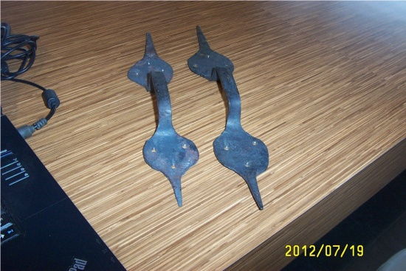

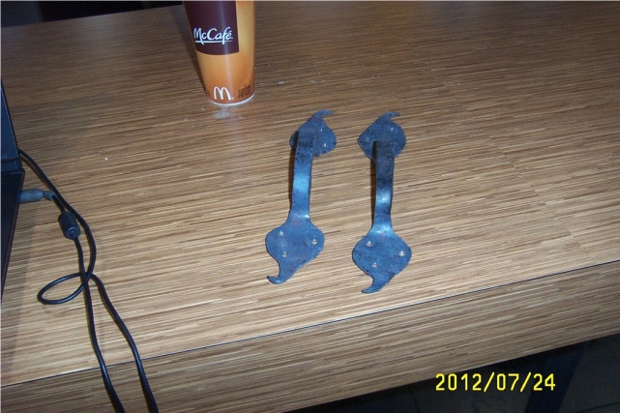
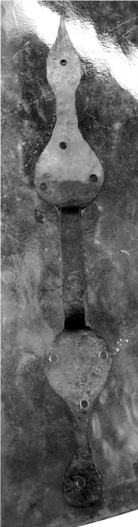
Excellent Websites
- www.iforgeiron.com
- https://sites.google.com/site/stuarttheblacksmith/home
- www.forgemagic.com
- www.anvilfire.com
- http://blacksmith.org/forums/

Beginner’s Corner
A lot of people new to this craft complain about the scarcity of blacksmith tools available. I have never had a hard time finding the equipment, because I know where to look. There is an excellent website called www.auctionzip.com. If you type the word “anvil” into the search engine, that website lists all local auctions, including farm auctions, where they are selling anvils. Usually accompanying anvils are other blacksmith tools like forges. You can also type “blacksmith” into that engine, and it will list all tools in proximity to you under that classification. Auctions are competitive, so be prepared to “fight” for what you want.
Another place where I have found a plethora of blacksmith tools is at the Golden Nugget Flea Market in Lambertville, in close proximity to where our meetings are. As shown earlier, Dave Boyer, one of our members, landed a very nice anvil at that venue. I also have scored blacksmith tools at the Trevose Fire Hall Flea Market on Street Road, and the Columbus Flea Market on Rte. 206 in New Jersey.
Another good place to get blacksmith tools is at our meetings. Several of us have extras, and if we can, we like to accommodate new members in the group.
Everyone here is familiar with craigslist. I have found a number of anvils and forges in proximity to Philadelphia on that website. A neat trick is to go to Delaware Craigslist, which is not very far away, to find anvils down there!

Boy Scout Meeting
One of our members, Bob Herrmann, is also a Scoutmaster for the Boy Scout Troop which meets at Maternity BVM School on Bustleton Avenue in Philadelphia. This coming Wednesday night, Sept. 26, at 4 PM, I am helping him to enable that troop to acquire Metalworking Merit Badges. We will be doing this on consecutive Wednesday evenings. I am bringing a portable forge and anvil, as is Bob! We shall post pictures in next month’s newsletter!

Elizabethtown Demo
On Saturday, Sept. 15, I gave a demo of blacksmithing at a colonial reenactment near the Bethlehem Pike, at the urging of Bob Herrmann. Pictures posted below! I even managed to recruit a new member, a teenager!
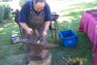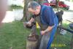

Trent House Demo
William Trent was an early 18th Century slave trader who lived in Philadelphia. Amidst a scandal involving his wife, he moved his entire family and business to a plantation on the Jersey side of the Delaware River, where Trenton is now, a city that bears his name. He lived there for several years, where he was poisoned by one of his slaves. The Director of the Trent House Museum Association invited me to do a blacksmithing reenactment during their annual open house, which occurs in the middle of October. I toured the mansion before doing the demonstration, and noticed that all the doors had arrow-style latches, forged by a blacksmith. They also had an open hearth kitchen, separate from the living quarters, where all the food was cooked over that hearth, as well as a warming kitchen, where food was warmed up IN the house before it was served. They lacked cooking utensils for these hearths, so during my demo, I forged a ladle and meat toasting fork for them, in the style that was au courant for that time period, back in 1719. Wealthy gentlemen, back in the 18th Century, preferred not to have the smells of food cooking wafting from the kitchens, which is why cooking hearths were separate from the manner house. The Association Director, so impressed that I forged these accurate utensils right in front of him, purchased them from me to display in the hearths. I am posting some pictures of the event, which was well attended and enjoyed by the visitors.
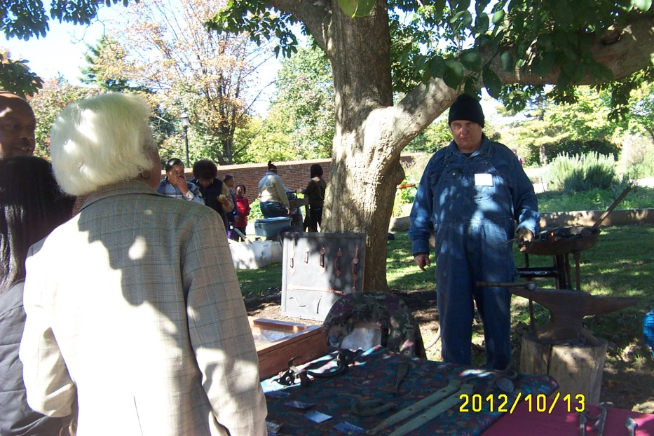

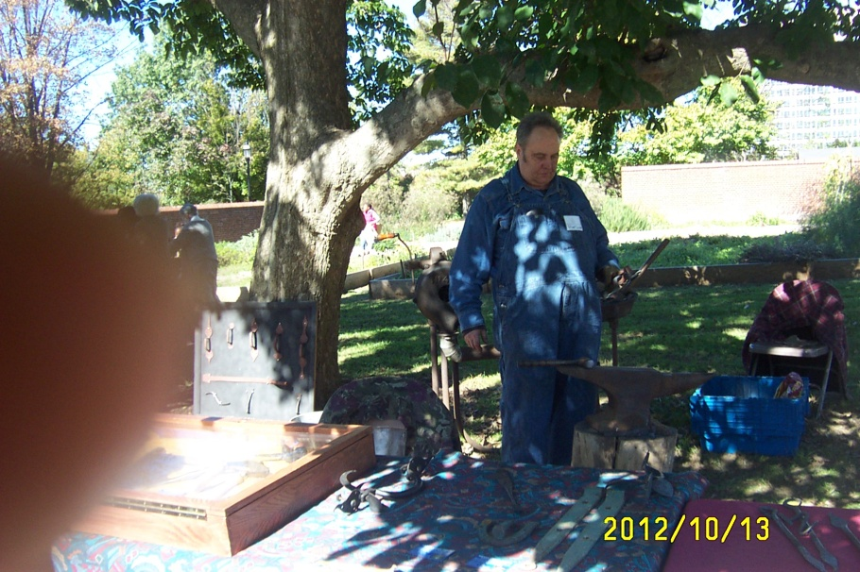

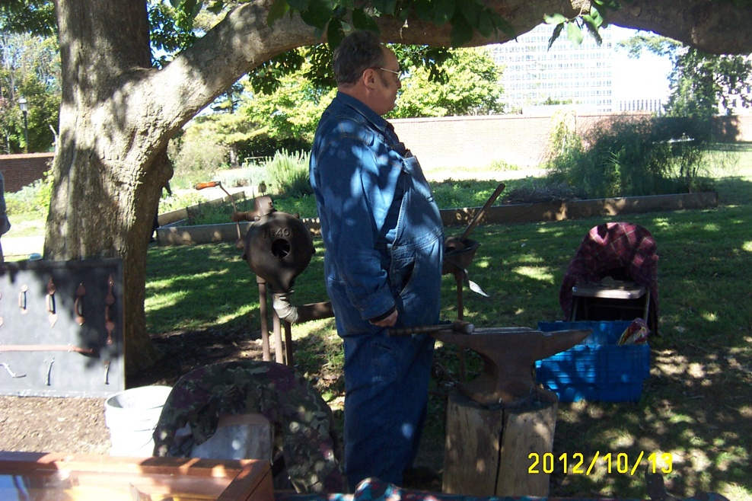

Makeshift Anvils

Earlier in the newsletter, I discuss acquiring anvils from traditional and untraditional sources. Lack of a regular anvil should actually be no deterrent from forging hot iron and steel. A trip to a scrap yard can yield all sorts of anvil substitutes, from forklift tines to big blocks of steel, industrial discards, which can serve as an anvil in a pinch, until you score a traditional euro or London pattern anvil to use. The only limit to what you can use is availability of large pieces of scrap at these places and your imagination. Bulldozer parts can also make excellent “anvils”. Give it a try!

THE RAIN IN SPAIN STAYS MAINLY ON THE CHAIN
Some lady came to me today and asked me to make her a rain chain. She told me that when visiting Latino Countries in this Hemisphere, like Guatamala and Nicaragua, she noticed that rather than rain gutters, they attach chain to the eaves of a roof to divert rainwater down the chains. In the spirit of WATER, I forged a hook end on the chain depicting a sea serpent! To forge the ends on the chain I drew out the one end to a long round point, then bent that round point around like the eye end of an eye bolt, using bending forks as prescribed in a previous newsletter. The serpent end of the hook got drawn down behind the head, and drawn down round, about half the thickness of the head. I forged a blunt taper in the front of the head for the nose, then locked the head in the vise while hot and punched two holes with a tiny punch for eyes. Finally, I bent the neck in a pair of bending forks mounted in my vise, to make the neck look lifelike. This works really nice when rain is falling down the chain and drips off the face of the serpent. To attach the eye end to the chain, heat up the eye of the hook yellow hot, then spread it open with needle nose pliers, then drop in the chain and close it by hammering it closed. Below are pictures of the finished product.

