Hammertyme: The Philadelphia Blacksmiths Guild

July 2012, Volume 1 Issue 7

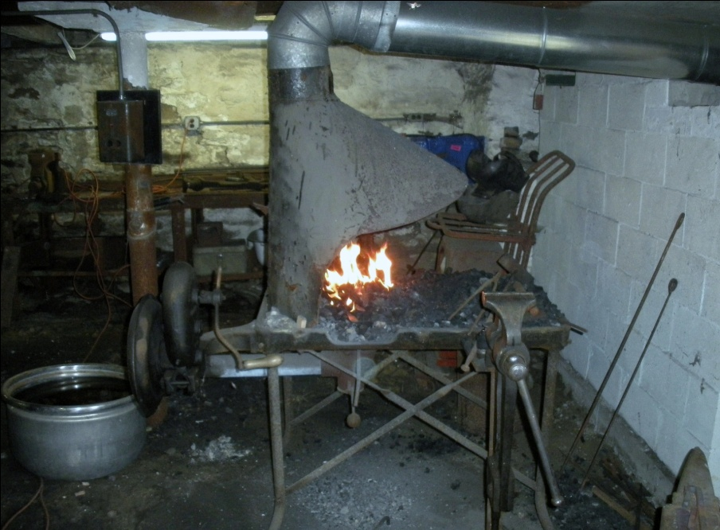

Group News

Thanks to Ben Suhaka and the people at the Holcomb-Jimison Farm Museum and Blacksmith Shop, we will have two meetings of our group in August. On Sunday, August 12, from 9AM-?, we will have our regular group meeting at the blacksmith shop, which is extremely participatory. Remember to bring work shoes and safety glasses, because you will be expected to participate in forging beautiful iron projects. Our meetings are open to neophytes to blacksmithing, as well as experienced smiths. Then exactly one week later, at the same venue, we will have our second monthly meeting in conjunction with the tool-swapping group that also meets at that location on Aug. 19. Farmers and tool swappers have been urged to bring blacksmithing tools to sell and swap to us, especially the newbies who lack the basic tools. Both meetings are located on NJ Route 29, in Lambertville, in close proximity to the police station there. Looking forward to both meetings!

July Meeting

We met at the Holcomb Jimison Farm Museum, where our President, Stuart Geisler, gave a lecture and demonstration on how to forge a Colonial door latch taken from the pages of the classic book “Early American Wrought Iron” by Albert Sonn. This set of tomes is a compendium of early American wrought ironwork done in the 18th century, complete with hand drawn pictures of these beautiful pieces. Albert Sonn hand drew all these hundreds of latches and strap hinges in 1928, which was a considerable project! After forging the pictured latch, Guild member Robert Herrmann tried his hand at forging a latch in the afternoon, and did a wonderful job!

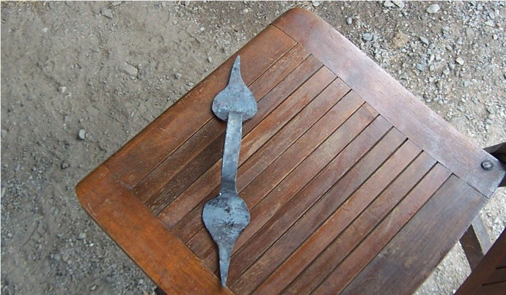

Pictured above is the latch that Stuart forged in the morning session. It is a copy of a latch on page 157 in Sonn’s treatise.
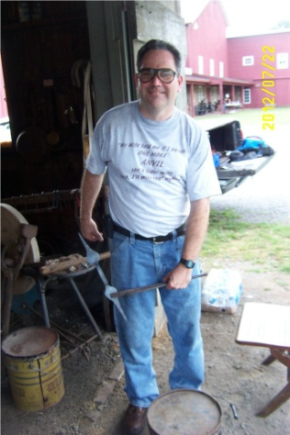
This is a picture of Robert holding the latch he forged in the afternoon in a pair of tongs. Bravo!
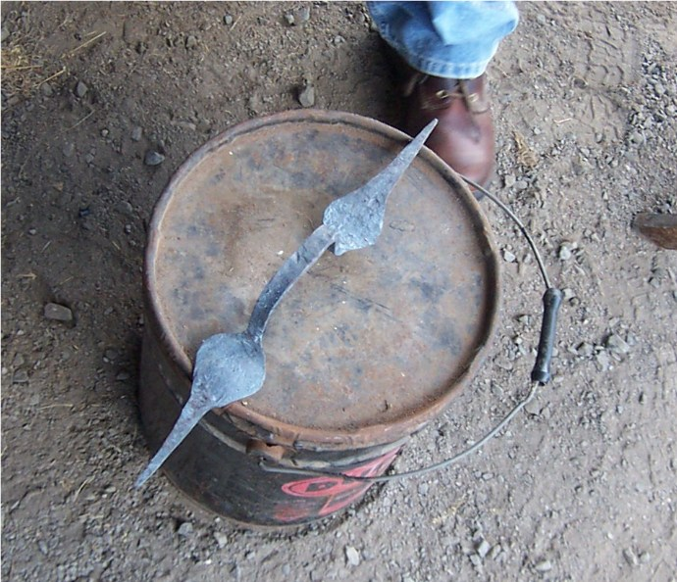
This next picture is a close-up of Bob’s latch! Very nice job of it, my friend!

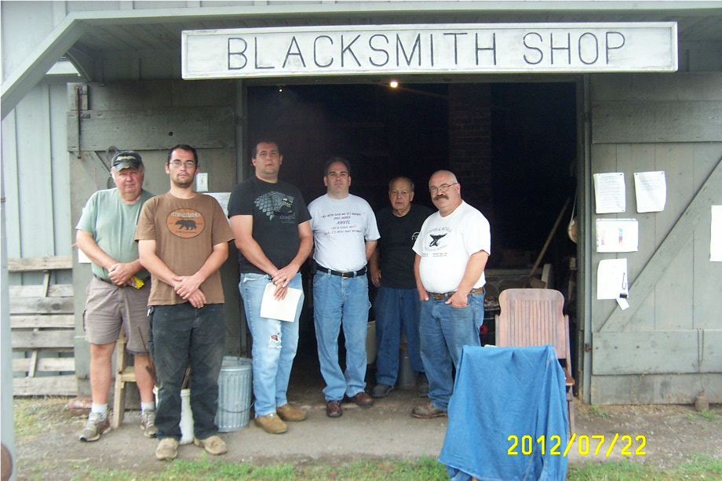
Finally, the last picture of our motley crew depicts, from left to right Josh Kavett, Ben Suhaka, Robert Herrmann, Andrew McMackin, Allan McMackin, and Josh’s friend Karl. Obviously, Stuart Geisler took the photo! Other participants came for the afternoon session, but alas, I was too lazy to take another picture!

More Club News
Josh Kavett, who attended our July Meeting, cordially invited our entire group to visit his Fisher Anvil Museum, which he curates. Josh has a complete collection, which is absolutely amazing, of every anvil ever manufactured by Fisher Eagle Anvil Works, in Trenton, NJ. He even owns a group of wooden patterns for casting these anvils, as well as the Patents for their manufacture. With over 350 anvils, Josh has devoted a lifetime to collecting and documenting these artifacts. Thank you, Josh. We will definitely have a meeting at your venue!

Forging Door Latches
In order to get the larger areas of a latch wide enough, especially forging leaves, one must start with enough material in order to get that part of the latch WIDE! That is why I start with either ¾ inch round rebar, or a metal strap that is at least inch and a half wide by quarter inch thick. Obviously, to forge a leaf, one must taper the end into a point. To get the wide part of the leaf wide enough, I cross pein the flat area on both sides, getting it wider and wider. I do this at a yellow heat, to make sure the leaf SPREADS. After a few heats of peining, I heat the flat part hot again and hammer it flat with the flat part of the hammer. The next step is to neck down the handle part right behind the flat part of the leaf. I do this by using the edge of the anvil, turning the piece repeatedly for symmetry. I repeat the exercise on the other side of the latch, forging an identical leaf, then necking down the handle identically to the other side. When the handle part is uniformly thick and at least 8 inches long, I bend the leaf at each end at a 90 degree angle, making the two leaves bend TOWARDS each other. Finally, I heat up the area just behind the right angle bend at both ends, bending the handle between two bending forks to eliminate the possibility of hammermarks on the handle or overflattened parts by overhitting to make the bends.
Pictured below are several latches I forged in this manner, right from Albert Sonn’s book, with variations. Enjoy!
