HAMMERTYME
NEWSLETTER OF THE PHILADELPHIA BLACKSMITH’S GUILD
VOLUME 1 ISSUE 2 January 2012

GOOD NEWS!
I am happy to say that our numbers are increasing. Our membership is up to 25 people and counting! Everyone attending our events is encouraged to bring friends, who might be interested in this craft. We are insuring the growth of blacksmithing in the Philadelphia Area! We want to recruit young and old, male and female, experienced and new to blacksmithing. See you at the meeting!
MISSION STATEMENT
As the birthplace of the United States of America, Philadelphia played a very important role in the development of this country. We have a rich tradition of blacksmithing in this city. During the 18th Century, Philadelphia was the second largest city in the British Empire. Everywhere you looked, there were blacksmith shops in this city. That proud tradition continued into the 20th Century, with some of the greatest blacksmiths in history setting up shops here, like Samuel Yellin, who employed hundreds of metalworking artisans in West Philadelphia, to the Keyser Brothers, to more recent times, where craftsmen like Christopher Ray hammered at their anvils. In honor of that tradition, we are forming this organization to continue the ironworking tradition set forth by our forefathers, to educate neophytes to this craft, to act as a gathering-place for people, young and old, experienced and those wanting to learn blacksmithing, and to demonstrate for the public a craft which is exciting, productive, and fun. The function of this newsletter, which will be forwarded on a regular basis, is to solidify the bonds between folks who love the excitement and creativity which forge and anvil induce.
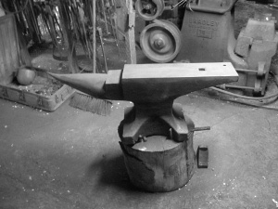
SCHEDULE OF EVENTS
Our next meeting will be on January 15, 2011, from 9:00 AM to 3:00 PM at the Holcolme-Jimison Farmer’s Museum in Lambertville, NJ. It is located on NJ Route 29(1605 Daniel Bray Highway), just north of the Lambertville Police Station. We will all collaborate on a project for the Museum, forging several Lima Bean Latches out of railroad spikes. Members are encouraged to bring their own forges and anvils, because our demonstrations and lectures are “hands-on”. These latches will be installed at the farmhouse at the museum, using techniques and styles au courant with 18thcentury styles. Members are also mandated to bring work shoes and safety glasses. To show our gratitude for providing a venue by all the museums in our meeting lists, we shall be forging projects which the venues can be happy with!
. Let the sparks fly, because it is HAMMERTYME!!!!!

OUR FIRST MEETING
Here are some pictures of our first meeting. A fun time was had by all! It was December 3, at the Ryerss Museum and Library in Burholme Park.
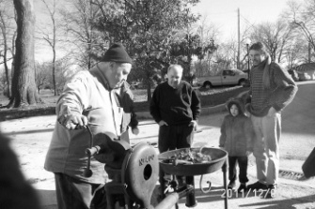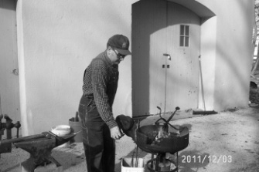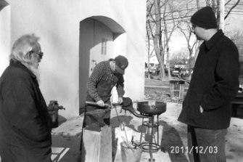
Stuart Geisler, Ben Suhaka, and Spectators Robert Herrmann at the Forge Dave Boyer, Bob Herrmann,
And John King
Our first event was very well attended, which bodes well for this craft. We had many spectators who signed up for our group! A good time was had by all!

BEGINNERS CORNER

Everyone has to start somewhere. After acquiring the basic equipment for blacksmithing, anvil, forge, hammer, and blacksmith vise, the first thing a new smith needs to know is how to light a fire, which was covered in the Charter Issue of this newsletter. A very important skill in blacksmithing is bending hot metal. This month’s beginner’s section will cover the use of vise mounted bending forks for bending iron and steel. Enjoy!

VISE MOUNTED BENDING FORKS
Options

VICE-MOUNTED BENDING FORKS
Posted by stewartthesmith, 22 June 2010 · 0 views

VICE-MOUNTED BENDING FORKS USED TO BEND A VARIETY OF CURVES
There are many good ways to bend curves in steel and iron. Many blacksmiths bend curves over the horn of the anvil, whether the curve is ½ inch in diameter, or five feet in diameter. When striking hot steel over the horn of the anvil, one by necessity has to leave hammer marks on the steel, simply because you are hitting hot soft material with a hardened surface of a hammer. Hammering a piece of steel mounted fast on a bending jig has the same problem, hitting hot material with a hard surface leaves impressions on the forging.
A nice alternative, easy to make, is a vice mounted bending fork. Because the blacksmith holds the bar of steel in tongs when bending hot steel between the tines of the fork, the torque increases towards bending the hot steel simply because of the length of the pair of tongs. This allows the smith to exert great force on the object he is bending, without leaving hammer marks.
Let me use this example of forging a chain link out of 5/8 inch round mild steel. To make the bending fork, simply take a piece of 5/8” round, which is commensurate with the size of the stock being used for the chain link, and bend it into a U-shape. Make absolute sure that when you bend the bar into the U-shape, the tines are about ¾” apart. The reason for this small gap between the tines is control of the hot bend. Please see figure 1.
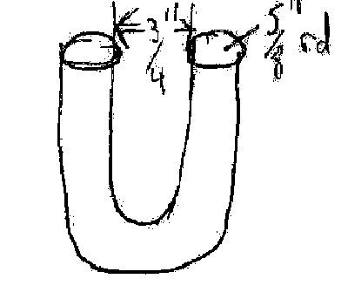
Figure 1
Bending Fork
This fork is then mounted and tightened in a blacksmith vice as in figure two. The tines of the bending fork should extend.upwards from the vice jaw about two inches or so. See figure 2.
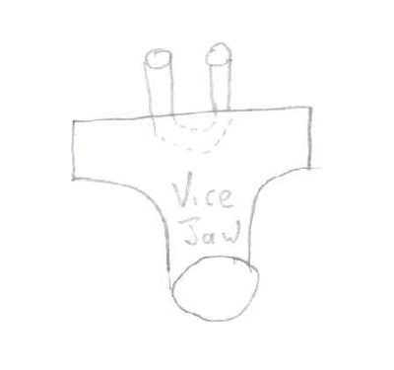
Figure 2
Bending Fork Locked in Vice
To bend oval links out of 5/8” steel, I cut 14 inch lengths of that material. I heat up one end of the bar to a yellow heat, then bend one end between the tines of the vice mounted bending forks. By making the bending forks tight with the tines close, I can either bend wide or sharp tight bends between the forks, bending the bar in increments as I see fit, which gives me excellent control of the radius of the bend. The crosshatched shaded areas are yellow-hot in my diagrams. By holding the cool end in long tongs, I can exert tremendous force on the bend because of the length of the tongs on which I am pulling, Of course, to decrease the need to flatten the work being bend, hold the work as horizontal as you can! Please see the series of figures 3a, 3b, 3c, and 3d.
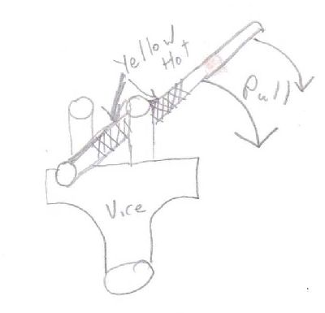
Figure 3a
Starting the Bend
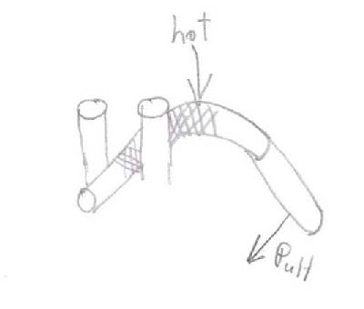
Figure 3b
Continuing the Bend Further, on the Same Heat
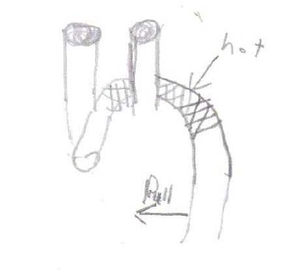
Figure 3c
Still Further on the Same Heat
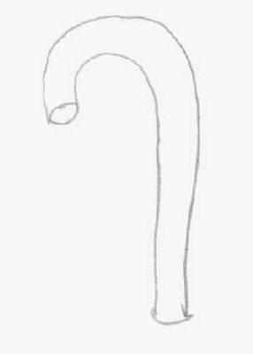
Figure 3d
One End of Link Finished
Once that end of the link is bent, heat up the other end to a yellow heat, then bend in a similar manner that end between the tines of the fork while hot. After a bit of practice, the bends at both ends of the link should be symmetrical, unless you are bending pear shaped links in which the radii of the two ends of the link are different. Either way, by having the tines close together, the blacksmith can bend any radius he wants between these forks. Figure 4 shows the second side of the incipient link being heated to a yellow heat, while figure 5 shows the finished link. If this finished link does not end up laying flat, simply heat up the whole link to an orange heat, then place it on a steel table and place a large steel plate on top of it, and whack the plate atop the link with a 20 pound sledgehammer to make it lay flat. This is preferable to flattening the link with a hammer on top of your anvil, which will leave unnecessary hammer marks
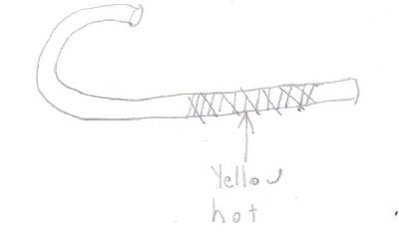
Figure 4
Opposite End of Link Being Heated
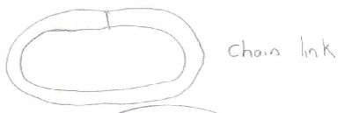
Figure 5
Finished Oval Link
One more thing…….I have seen a lot of blacksmiths try to use bending forks which are mounted in a hardy hole. I believe my vice mounted bending forks are superior to these because most hardy-hole mounted forks have play inside the hardy hole, which causes the smith trying to bend steel to lose torque through play in the tool. Even if there is no slack in the hardy hole, torquing a bend between tines can cause the whole anvil to move, which again causes a loss of torque. My simple forks preclude wobble and play, because the forks are LOCKED in the vice. Also, because my tines are close together, different from most hardy-hole forks, the blacksmith has far better control of the radius being bent between the forks. See figure 6.
My link
Figure 6
Anvil Mounted Bending Forks
Final notes: I have two more notes regarding the use of these forks. Firstly, the size of the material being bent between these forks should be commensurate with the size of the material used in making these forks. It wouldn’t work to try to bend three inch round between a fork made out of half-inch round. Secondly, remember that you are bending hot steel between the tines. Failure to realize this could result in the blacksmith burning his/her elbows on an apparently cold bending fork. With these forks, a blacksmith should be able to bend just about anything with enough practice, from chain links to scrolls, from shackles to basketball rims. Happy Forging!

Rust Resistant Finish
By Sage Nippulini
The traditional 3 part blacksmith's coating is beeswax, turpentine, BOILED linseed oil in equal parts. It is applied to metal that is just hot enough to make it smoke. You're supposed to rub down the workpiece while still warm, and wait about 3 days for it to develop full strength. This is a nice mixture, but takes a lot of work to make. Boiling linseed oil comes with its disadvantages and can flare up big time. Cooking turpentine will make the whole house stink up pretty badly (can we say angry housewife?). I have come up with a more user friendly version, this is my recipe: beeswax, candles, quenching oil (used motor oil or hydraulic oils), clear gloss polyurethane. Put the beeswax and candles in an old coffee can. Hang it with wire and torch the can evenly to liquify the waxes, stir in the oil and gloss while everything is still liquid. Then, I pour the liquid mixture into empty TIG filler rod tubes and let cool at least overnight. Once everything is solidified, simply push the wax out of the tubes and break apart the resulting rods. I use this by heating the piece to a black heat, then rub the wax stick into the piece, it will smoke and stink a bit, so use ventilation or outdoors. Once everything is cool, I wirebrush the surface for a nice soft finish. When used indoors, this coating should last decades
TAILGATING
Any club members desiring to sell something should sent me a picture, description, price, and phone number via email to the below email address. The item(s) will be included in the next newsletter.
Contact Information: Editor Stuart Geisler, 215-768-5735 stampmanstuart@juno.com

