HAMMERTYME
NEWSLETTER OF THE PHILADELPHIA BLACKSMITH’S GUILD
VOLUME 1 ISSUE 1 DECEMBER 2011
MISSION STATEMENT
As the birthplace of the United States of America, Philadelphia played a very important role in the development of this country. We have a rich tradition of blacksmithing in this city. During the 18th Century, Philadelphia was the second largest city in the British Empire. Everywhere you looked, there were blacksmith shops in this city. That proud tradition continued into the 20th Century, with some of the greatest blacksmiths in history setting up shops here, like Samuel Yellin, who employed hundreds of metalworking artisans in West Philadelphia, to the Keyser Brothers, to more recent times, where craftsmen like Christopher Ray hammered at their anvils. In honor of that tradition, we are forming this organization to continue the ironworking tradition set forth by our forefathers, to educate neophytes to this craft, to act as a gathering-place for people, young and old, experienced and those wanting to learn blacksmithing, and to demonstrate for the public a craft which is exciting, productive, and fun. The function of this newsletter, which will be forwarded on a regular basis, is to solidify the bonds between folks who love the excitement and creativity which forge and anvil induce.
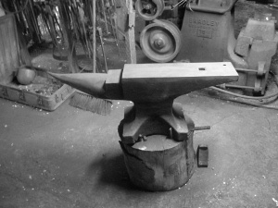
SCHEDULE OF EVENTS
Our first meeting will be on December 3, 2011, from 10:00 AM to 3:00 PM at the Ryerss Museum Carriage house in Burholme Park, where charter members will give a live demonstration of blacksmithing and their wares during the Annual Ryerss Holiday Bazaar Event
at that location. While demonstrating, we will recruit people interested in trying out this craft as a hobby, as well as disseminating information about blacksmithing. At the end of the event, we will have an organizational meeting to discuss future meetings, events, and recruiting. Safety will be stressed during the entire event. Let the sparks fly, because it is HAMMERTYME!!!!!
BEGINNERS CORNER

Everyone has to start somewhere. After acquiring the basic equipment for blacksmithing, anvil, forge, hammer, and blacksmith vise, the first thing a new smith needs to know is how to light a coal fire in a forge. Control of fire is necessary knowledge in any blacksmithing endeavor. Here is an article I wrote on this subject, for beginners, many years ago.

TO LIGHT A FIRE
The first impediment that the novice faces is starting and maintaining a coal fire in a forge. In order to forge anything with any level of efficiency and competency, a suitable fire for the project to be forged must be started and maintained. Although other blacksmiths may make fires differently from the way I was taught, perhaps this article can help some incipient blacksmiths to heat steel easily, using these methods.
I recently attended a forge-in in which the demonstrators took a lunch break. They let the fire go out. When it was time for the next smith to give his lecture, he had a hard time lighting up the coal for the next demo. I know there are different kinds of coal, and different qualities. However, the method for fire starting that I learned will hopefully enable smiths to light up easiy, with a minimum of work to do so.
After cleaning out the ash basin below the fire pot, remove all the ash, coal, and clinker out of the fire pot. Ball up about five pieces of newspaper, and place them in the fire pot. The next step is to tear up corregated cardboard into four inch by four inch pieces and place them over the balled up newspaper in a pile of cardboard. Take a piece of newspaper and roll it up like a fuse, then light one end of it. That rolled up, lit-at-one- end newspaper then gets used like an igniter to light up the balled-up newspaper under the stack of cardboard pieces. As soon as the balled up newpaper catches fire, quickly hand-crank your hand cranked blower with your left hand, while shovelling coal onto the cardboard with your right hand. You know you will be successful in starting your coal fire if you see yellow smoke coming out of the coal with the burning, fanned cardboard below it. If you have a rheostat-controlled forge blower, perform the previous steps using the electric blower to fan the cardboard with coal piled atop that.
After a short while, if you used enough cardboard pieces lit up under the coal, that coal will turn to coke…….very hot coke. To make more coke for your fire, surround the ignited coke with more coal; the hot burning coke at the center of the fire in the fire pot will burn off the water and sulfur in the coal to form more coke. In this way, your fire is an organic thing, needing to be fed while you use the center of the fire to heat steel or iron.
After awhile, depending upon the quality of your coal, a clinker will form in your fire pot after a number of heats. Clinker is a combination of rock, slag, and impurities in your coal, along with scale that came off the steel and iron which you have been forging. Due to gravity, it sinks to the bottom of your firepot, and impedes the flow of air which stokes your burning coke at the heart of your fire. Clinker is an impediment to heating your steel evenly. To get rid of it, quickly rake all of the hot coke towards your cowl or exhaust in your chimney, shovel out all the clinker down in the firepot, then turn on the fan as you scoop the still-hot coke back into the firepot, FANNING it. Then, as your hot fire is restored, rake more fresh coal surrounding the sides of the hot coke, which will in turn replenish the coke around the sides needed to keep your fire constantly running. To control the growth of coke from coal around the sides of the fire, you can use a sprinkler can dousing the edges with water to slow down the coking process on the edges of your forge fire. I have had very poor results with clinker breakers on standard firepots. They generally do not work well. The way I just outlined cleaning a clinkered fire is far more reliable. The master who taught me did his fires in this manner, and it is how his dad did it, and his dad’s dad.
If you are going to take a lunch break and want your fire still smoldering when you return, you can do what is called “banking your fire”. Instead of putting a small amount of coal around the edges of your fires in order to coke it, make a large pile of coal at the edge of the fire away from the cowl. Then turn up the fan four about two minutes, then turn it off. That big pile of coal at the edge of your fire acts as insulation, which holds in the heat at the center of your firepot. When you return, and turn on the fan again, or crank your hand cranked fan, your fire will restore to its former glory!
I sincerely hope that these fire making tips will help novices to start and maintain a coal fire. Future articles of mine will cover the different types of fire for different types of forging operations. Good luck!

Rust Resistant Finish
By Sage Nippulini
The traditional 3 part blacksmith's coating is beeswax, turpentine, BOILED linseed oil in equal parts. It is applied to metal that is just hot enough to make it smoke. You're supposed to rub down the workpiece while still warm, and wait about 3 days for it to develop full strength. This is a nice mixture, but takes a lot of work to make. Boiling linseed oil comes with its disadvantages and can flare up big time. Cooking turpentine will make the whole house stink up pretty badly (can we say angry housewife?). I have come up with a more user friendly version, this is my recipe: beeswax, candles, quenching oil (used motor oil or hydraulic oils), clear gloss polyurethane. Put the beeswax and candles in an old coffee can. Hang it with wire and torch the can evenly to liquify the waxes, stir in the oil and gloss while everything is still liquid. Then, I pour the liquid mixture into empty TIG filler rod tubes and let cool at least overnight. Once everything is solidified, simply push the wax out of the tubes and break apart the resulting rods. I use this by heating the piece to a black heat, then rub the wax stick into the piece, it will smoke and stink a bit, so use ventilation or outdoors. Once everything is cool, I wirebrush the surface for a nice soft finish. When used indoors, this coating should last decades

TAILGATING
This section is for members to advertise their excess blacksmith tools. It is free for all members. Please include a telephone number, price, name, and describe, to the best of your ability, the items you have for sale.

For Sale:
259 Pound Peter Wright Anvil, rings like a bell, some rough edges, pretty good condion.

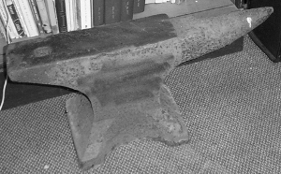
Price: $600.00 Contact Stuart Geisler 215-768-5735

148 Pound Peter Wright, excellent condition, rings like a bell
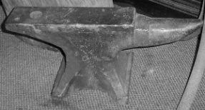

Price $350.00 Stuart Geisler 215-768-5735
50 pound Vulcan, a typical Vulcan, only good for a bench anvil, but very portable, fair condition, cheap!

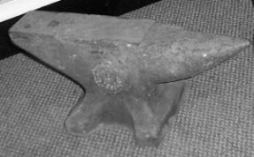
Price $100.00 Stuart Geisler 215-768-5735

Cannedy Otto Hand Cranked Blower, works well, makes a lot of air!
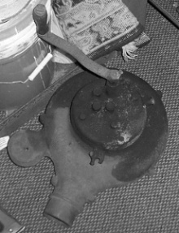
Price $200.00 Stuart Geisler 215-768-5735

Blacksmith Leg Vise, 4 ½ inch jaws, decent shape, fully functional, very heavy for its size, clean!
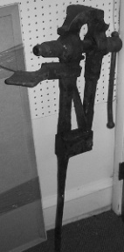
Price $150.00 Stuart Geisler 215-768-5735
Contact Information: Editor Stuart Geisler, 215-768-5735 stampmanstuart@juno.com

