HAMMERTYME
NEWSLETTER OF THE PHILADELPHIA BLACKSMITH’S GUILD
VOLUME 1 ISSUE 6 June 2012

OUR GROUP IS EXPANDING
I am happy to say that our numbers are increasing. Our membership is up to 30 people and counting, due to new people attending our events! Everyone attending our events is encouraged to bring friends, who might be interested in this craft. We are insuring the growth of blacksmithing in the Philadelphia Area! We want to recruit young and old, male and female, experienced and new to blacksmithing. See you at the meeting! On that note, because it costs money to print and mail so many newsletters, it is mandatory that we charge dues to offset the costs of the Newsletter. I am enclosing a SASE with this Newsletter for a check or money order for dues, which I am trying to keep as a minimum. $20 dollars a year, for a quality monthly newsletter, is only a pittance for such a wealth of information about Blacksmithing. Thank you for your participation!
MISSION STATEMENT
As the birthplace of the United States of America, Philadelphia played a very important role in the development of this country. We have a rich tradition of blacksmithing in this city. During the 18th Century, Philadelphia was the second largest city in the British Empire. Everywhere you looked, there were blacksmith shops in this city. That proud tradition continued into the 20th Century, with some of the greatest blacksmiths in history setting up shops here, like Samuel Yellin, who employed hundreds of metalworking artisans in West Philadelphia, to the Keyser Brothers, to more recent times, where craftsmen like Christopher Ray hammered at their anvils. In honor of that tradition, we are forming this organization to continue the ironworking tradition set forth by our forefathers, to educate neophytes to this craft, to act as a gathering-place for people, young and old, experienced and those wanting to learn blacksmithing, and to demonstrate for the public a craft which is exciting, productive, and fun. The function of this newsletter, which will be forwarded on a regular basis, is to solidify the bonds between folks who love the excitement and creativity which forge and anvil induce.
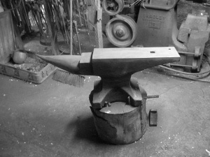
SCHEDULE OF EVENTS
Our next meeting will be at Pennsbury Manner, right on the Delaware River in close proximity to US Route 13. The blacksmith shop there is an accurate recreation of the original shop on the plantation where William Penn resided and established his colony in Pennsylvania, complete with a stone forge with leather bellows, and a church window anvil date-stamped 1690. Stuart Geisler will demonstrate forging knife blades leaving a minimum of hammer marks, which are very hard to grind out of a knife blank. We will be meeting on Saturday, June 23, from 9 AM to 4 PM. Bring goggles and work shoes!
Our Guild Meeting for May was at the Holcomb-Jimison Farm Museum, right on NJ Route 29, in close proximity to the Police Station in Lambertville. We forged wrought iron kitchen utensils, which the Museum will later sell at a June Fundraising Event! We will be meeting on Sunday, May 13 at that location.
. Let the sparks fly, because it is HAMMERTYME!!!!!

OUR JANUARY MEETING
Our January meeting took place at the Holcomb-Jimison Farm Museum and Blacksmith Shop in Lambertville, NJ on NJ Route 29. Someone donated humongous blacksmith tongs, over five feet long, to the museum. The resident blacksmith there, Ben Suhaka, needed to forge chains in order to fasten those tongs to a vertical support pole in the blacksmith shop, so I gave a tutorial on forging chain links, using both bending forks and the anvil horn in order to shape the links for the chain. The I subsequently taught the entire gathering how to forge weld the chain links fast so that they hold. Everyone there did a very nice job, despite the frigid ambient conditions!
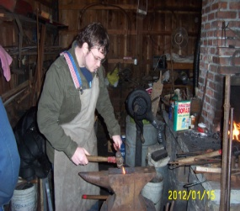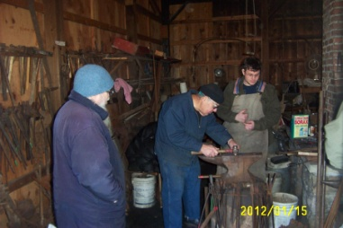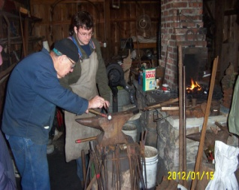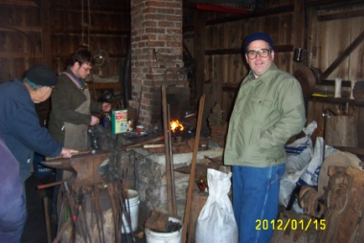
Pictured, left to right, are Jay “Jerky, Dave Boyer Ben Suhaka and Jay, Ben and Jay, and Ben Jay and Bob Herrmann

OUR FEBRUARY MEETING
Our February Meeting took place on the grounds of Pennsbury Manor, where the Colony and State of Pennsylvania started, in the late sixteen hundreds. Because the King of England borrowed a vast sum of money to finance wars from John Penn, William’s father, in order to pay off the debt, the King deeded William Penn an entire Colony in the New World, which was called Pennsylvania in honor of the owner of the Plantation. In the well-equipped shop on the plantation grounds is a 300 pound “church window” anvil, date-stamped “1690”, which was probably the anvil used by William Penn’s blacksmith himself! Robert Herrmann, the current blacksmith on the site, allowed us to hammer on this tremendous historical treasure! Because the weather was nice and balmy for a mid-winter day, we got a lot of forging work done during the meeting, including tong racks for Robert Herrmann to use for his tools, a very nifty towel rack forged by Dan Manders for his home, and some very nicely executed wall hooks by Jay “Jerky’s” dad John, who is a new member of our group and shows an enormous affinity for hand forging! Enjoy the pictures!

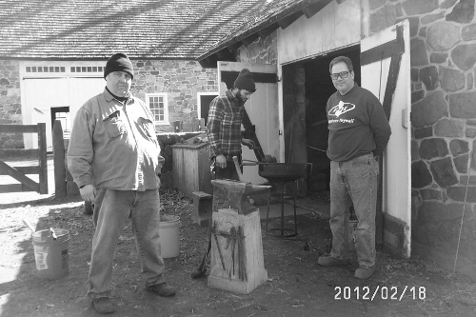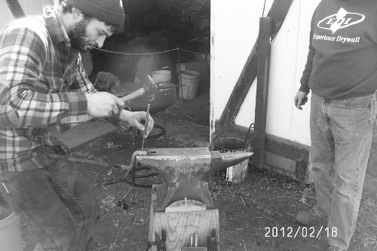

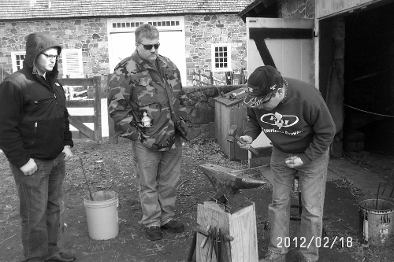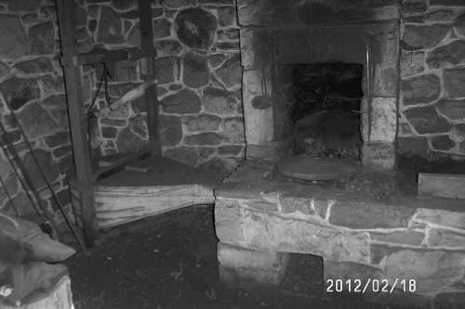

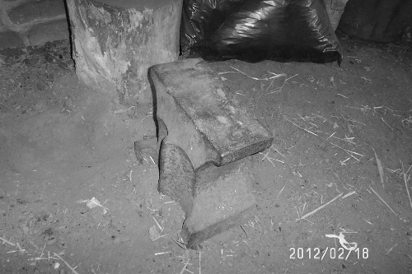
BEGINNERS CORNER

Everyone has to start somewhere. After acquiring the basic equipment for blacksmithing, anvil, forge, hammer, and blacksmith vise, the first thing a new smith needs to know is how to light a fire, which was covered in the Charter Issue of this newsletter. A very important skill in blacksmithing is bending hot metal. Last month’s beginner’s section covered the use of vise mounted bending forks for bending iron and steel. In February, I described how to forge weld a chain link. In March, I discussed the topic of swinging a hammer.
BASICS OF HAMMERING
Most beginners have several misconceptions about swinging a hammer, which translates to poor technique at the anvil. When a blacksmith is standing next to his/her anvil, the height of the face should be main knuckles-height, neither higher nor lower than that. When a hammer is properly swung, this insures a level blow, and eliminates hammer-marks on the finished piece. Many neophytes, unsure of swinging, swing from the shoulder, “pushing” the hammer face. This is the wrong way to swing a hammer, and results in bursitis and work riddled with hammer-marks. The proper way to swing a hammer is at the elbow, which translates to a level hammer blow, with full force, using the weight of the hammer to do the work, and not your shoulder. To get used to this, I recommend that in order to practice, rather than hammering on hot steel on your anvil, practice by hammering on a wooden plank placed atop your anvil face, in order to get the knack of delivering full-force hammer blows.
When I served my apprenticeship, under a Russian-born master, I had the misconception that the hand should grasp the hammer handle with the thumb fully around the handle. Carpenters swing their hammers thusly because they keep hitting a nail, over and over again, at the same angle. Blacksmithing consists of delivering progressively corrective hammer blows in order to minimize the effect of the previous hammer blow, necessitating much finer control over the hammer angle of impact. Therefore, blacksmiths, in order to exert that extra control, place their thumbs atop the hammer handle, actuating much finer angle control to the blows of the hammer. Separating us humans from lower primates are opposable thumbs, which allow us to exert fine control with our thumbs over the tools we use. Might as well employ every advantage we can over our tools, which includes the God-given advantage of opposable thumbs!

ANVIL POSITIONING
Most blacksmith shops have anvils, and where you place them in relation to the forge is critical. An anvil should only be placed one turn or step away from the forge. The further a forge is from the anvil, the more heat you lose in the piece you are forging between the forge and the anvil. For larger forgings, which retain the heat longer, you have more latitude. For small forgings, it is very important that the anvil be in close proximity to the forge. Standing erectly, with your arm hanging down, the anvil should be set on a stump or stand so that your knuckles just touch the anvil face. That way, when you swing a hammer, hitting a hot piece of steel, the steel or iron will get the full impetus of the blow!

FORGING A KNIFE
As a preliminary for our June Meeting, everyone, before we start, needs to know what to expect. First of all, in order for a blade to hold an edge, it must be medium-high carbon steel, so the material selected is important. I like to use spring steel, which is either 1080, or alloyed 5160, which is used in leaf springs for cars. The first step in forging a blade is to forge the tang, which is the part of the knife that the handle surrounds. To do this, I fuller the leaf spring sideways, which separates the blade from the tang. Then I forge down the area behind the fullering to make a tang. Next, I forge a taper where the point of the knife will be. The edges of the blade need to be beveled, which can be forged. If you only flatten the beveled part of the blade, the blade will hook like a horseshoe. To prevent this, and keep the blade straight, I hammer the blade in the wrong direction over the anvil, bending it so that when I forge the bevel on the blade, the blade straightens. Hammer control is essential when forging these bevels, and that is why I describled hammer control in the previous installment of this publication. I will also demonstrate how to heat treat the blade, after forging. The better one controls the angle of the hammer blows, the less hammer marks, and therefore much less grinding results.
MEMBER NEWS
One of our newest members, Dan Manders of Philadelphia, just acquired a very nice triphammer, a Scranton 70 pounder that he and I are rebuilding. The job is coming along very well, and this is an excellent hammer he purchased. Below, I am posting pictures of his new “toy”, in various stages of restoration. Dan has a beautiful shop, and has kindly offered his facility as a future meeting place for our group! Dan’s shop is alongside a wooden boatbuilding shop, where they hand craft wooden sailing vessels!
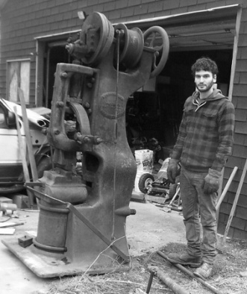

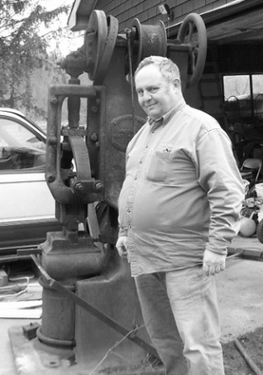

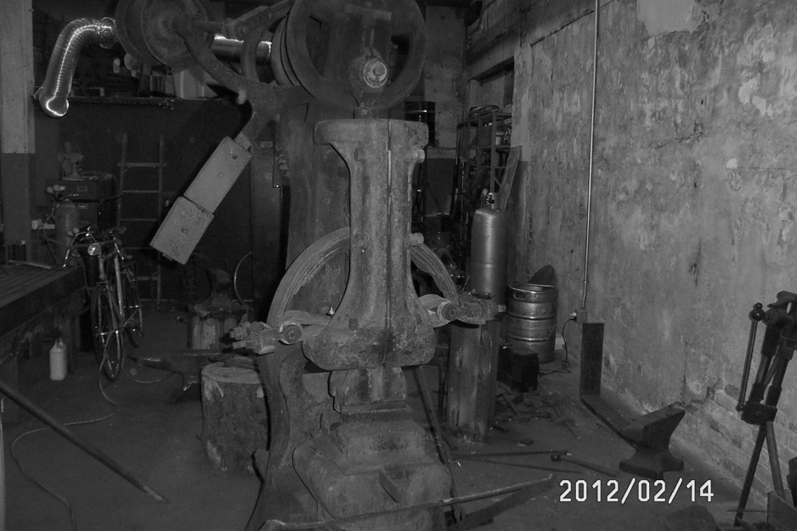
Recently, a young gentleman named Matt Gilbert joined our group. Along with several friends interested in blacksmithing, they meet every Friday night in Southwest Philadelphia, at a blacksmithing coop at 5007 Warrington, after 8 PM. These are a very enthusiastic group of blacksmiths, and it is worth your while “hanging” with them. I helped one of them, a young guy named “Miles”, tune his John Deere 35 pound triphammer. They are also invited to our meetings as well. For contact information, call me on my cellphone!
Jay Eibelheuser, who I affectionately call Jay “Jerky”, creates masterpieces in the culinary art of creating inventive types of jerky, from beef to bacon, from sweet potato to tofu, from alligator meat to tofu jerky. He also has a brilliant idea on marketing his products, using a branding iron to burn his logo into the top of various cigar boxes, which shall house his jerky samplers. He joined our group in order to fashion a special branding iron to use to place his logo onto the cigar boxes. Our group, under his guidance, is about to accommodate his wish, and create a product-based logo-installer for his novel products. And besides, all blacksmiths that I know love to eat!
Finally, Ben Suhaka, Guild member, recently attended a hammer-in in Central Maryland run by The BGCM, or the Blacksmiths Guild of 0f Central Maryland at the Carroll County Farm Museum. One of the demonstrators, knifemaker Mark Sentz, gave a tutorial on knife making. Knives are really a superior tool, form follows function with knives, and nice knives follow nature, where there are seldom straight lines. Because of crystalline structure, form does follow function, so forging a blade is superior to stock removal. Ben also attended a tutorial on forging colonial hardware, where he learned that holding hot steel in a vice horizontally grips the material better than vertically because of the jaws’ surface area, which increases if you grip horizontally.

Any club members desiring to sell something should sent me a picture, description, price, and phone number via email to the below email address. The item(s) will be included in the next newsletter.

EXCELLENT BLACKSMITHING WEBSITES
- www.anvilfire.com
- www.forgemagic.com
- www.iforgeiron.com
- http://blacksmith.org/forums/forum.php
- https://sites.google.com/site/stuarttheblacksmith/home
On the last site mentioned, my website, I have devoted a page to our group!

ONE MORE THING
To the experienced members of our group, especially those who work in public venues like museums, in order to spread this craft, let’s try to recruit more neophytes and interested people into our group. We DO have a lot to offer to anyone dreaming of being a blacksmith!
