HAMMERTYME
NEWSLETTER OF THE PHILADELPHIA BLACKSMITH’S GUILD
VOLUME 1 ISSUE 4 March 2012

OUR GROUP IS EXPANDING
I am happy to say that our numbers are increasing. Our membership is up to 30 people and counting, due to new people attending our events! Everyone attending our events is encouraged to bring friends, who might be interested in this craft. We are insuring the growth of blacksmithing in the Philadelphia Area! We want to recruit young and old, male and female, experienced and new to blacksmithing. See you at the meeting! On that note, because it costs money to print and mail so many newsletters, it is mandatory that we charge dues to offset the costs of the Newsletter. I am enclosing a SASE with this Newsletter for a check or money order for dues, which I am trying to keep as a minimum. $20 dollars a year, for a quality monthly newsletter, is only a pittance for such a wealth of information about Blacksmithing. Thank you for your participation!
MISSION STATEMENT
As the birthplace of the United States of America, Philadelphia played a very important role in the development of this country. We have a rich tradition of blacksmithing in this city. During the 18th Century, Philadelphia was the second largest city in the British Empire. Everywhere you looked, there were blacksmith shops in this city. That proud tradition continued into the 20th Century, with some of the greatest blacksmiths in history setting up shops here, like Samuel Yellin, who employed hundreds of metalworking artisans in West Philadelphia, to the Keyser Brothers, to more recent times, where craftsmen like Christopher Ray hammered at their anvils. In honor of that tradition, we are forming this organization to continue the ironworking tradition set forth by our forefathers, to educate neophytes to this craft, to act as a gathering-place for people, young and old, experienced and those wanting to learn blacksmithing, and to demonstrate for the public a craft which is exciting, productive, and fun. The function of this newsletter, which will be forwarded on a regular basis, is to solidify the bonds between folks who love the excitement and creativity which forge and anvil induce.
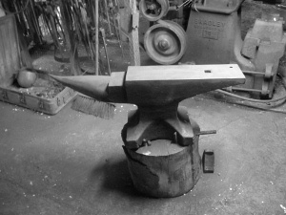
SCHEDULE OF EVENTS
Our next meeting will be on March3, 2012, from 9:00 AM to 3:00 PM at Ryerss Museum and Library, which is located at Cottman and Central Avenues in Philadelphia. This meeting of ours will be coincidental with a celebration at the Museum, Robert Ryerss’ Birthday We will all collaborate on a project for the group, forging a branding iron at the request of one of our members. Members are encouraged to bring their own forges and anvils, because our demonstrations and lectures are “hands-on”. Members are also mandated to bring work shoes and safety glasses. To show our gratitude for providing a venue by all museums in our meeting lists, we shall be forging projects which the venues can be happy with! Don’t forget to bring a friend!
. Let the sparks fly, because it is HAMMERTYME!!!!!

OUR JANUARY MEETING
Our January meeting took place at the Holcomb-Jimison Farm Museum and Blacksmith Shop in Lambertville, NJ on NJ Route 29. Someone donated humongous blacksmith tongs, over five feet long, to the museum. The resident blacksmith there, Ben Suhaka, needed to forge chains in order to fasten those tongs to a vertical support pole in the blacksmith shop, so I gave a tutorial on forging chain links, using both bending forks and the anvil horn in order to shape the links for the chain. The I subsequently taught the entire gathering how to forge weld the chain links fast so that they hold. Everyone there did a very nice job, despite the frigid ambient conditions!
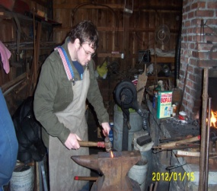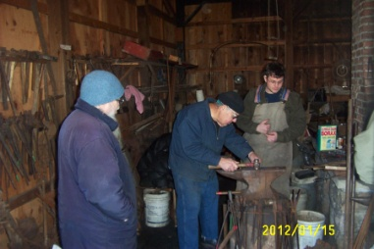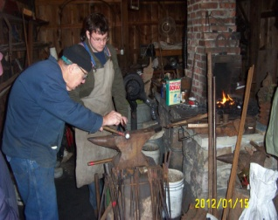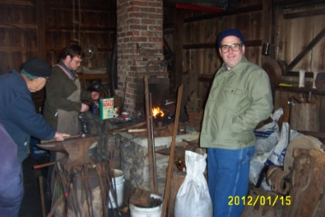
Pictured, left to right, are Jay “Jerky, Dave Boyer Ben Suhaka and Jay, Ben and Jay, and Ben Jay and Bob Herrmann

OUR LAST MEETING
Our February Meeting took place on the grounds of Pennsbury Manor, where the Colony and State of Pennsylvania started, in the late sixteen hundreds. Because the King of England borrowed a vast sum of money to finance wars from John Penn, William’s father, in order to pay off the debt, the King deeded William Penn an entire Colony in the New World, which was called Pennsylvania in honor of the owner of the Plantation. In the well-equipped shop on the plantation grounds is a 300 pound “church window” anvil, date-stamped “1690”, which was probably the anvil used by William Penn’s blacksmith himself! Robert Herrmann, the current blacksmith on the site, allowed us to hammer on this tremendous historical treasure! Because the weather was nice and balmy for a mid-winter day, we got a lot of forging work done during the meeting, including tong racks for Robert Herrmann to use for his tools, a very nifty towel rack forged by Dan Manders for his home, and some very nicely executed wall hooks by Jay “Jerky’s” dad John, who is a new member of our group and shows an enormous affinity for hand forging! Enjoy the pictures!

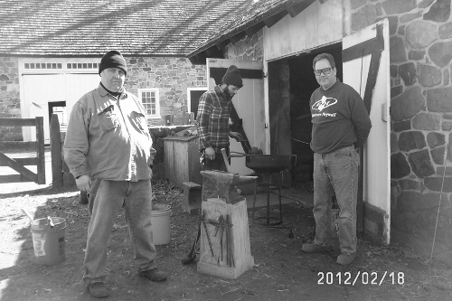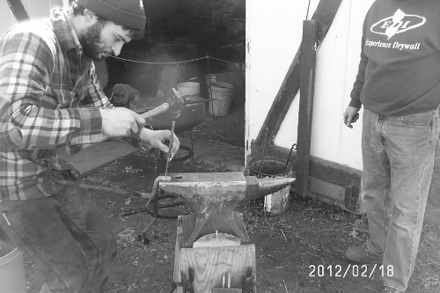

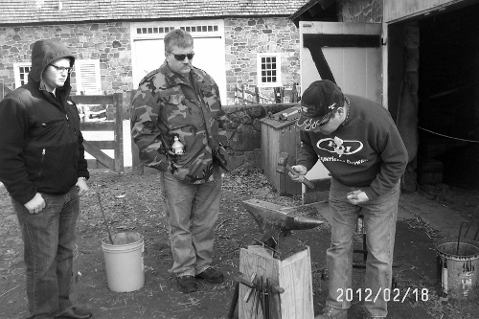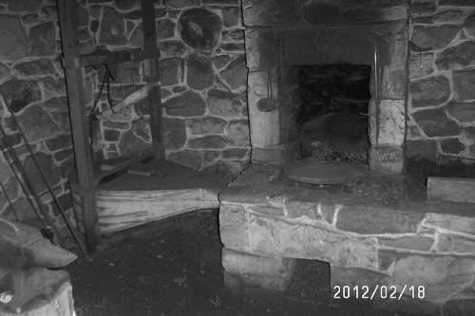

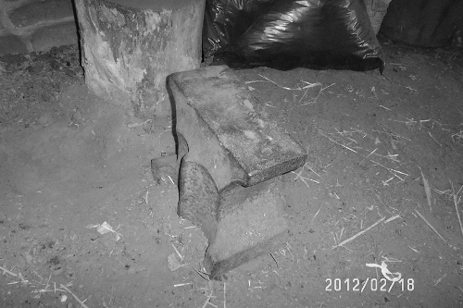
BEGINNERS CORNER

Everyone has to start somewhere. After acquiring the basic equipment for blacksmithing, anvil, forge, hammer, and blacksmith vise, the first thing a new smith needs to know is how to light a fire, which was covered in the Charter Issue of this newsletter. A very important skill in blacksmithing is bending hot metal. Last month’s beginner’s section covered the use of vise mounted bending forks for bending iron and steel. In February, I described how to forge weld a chain link. This month, I will discuss the topic of swinging a hammer.
BASICS OF HAMMERING
Most beginners have several misconceptions about swinging a hammer, which translates to poor technique at the anvil. When a blacksmith is standing next to his/her anvil, the height of the face should be main knuckles-height, neither higher nor lower than that. When a hammer is properly swung, this insures a level blow, and eliminates hammer-marks on the finished piece. Many neophytes, unsure of swinging, swing from the shoulder, “pushing” the hammer face. This is the wrong way to swing a hammer, and results in bursitis and work riddled with hammer-marks. The proper way to swing a hammer is at the elbow, which translates to a level hammer blow, with full force, using the weight of the hammer to do the work, and not your shoulder. To get used to this, I recommend that in order to practice, rather than hammering on hot steel on your anvil, practice by hammering on a wooden plank placed atop your anvil face, in order to get the knack of delivering full-force hammer blows.
When I served my apprenticeship, under a Russian-born master, I had the misconception that the hand should grasp the hammer handle with the thumb fully around the handle. Carpenters swing their hammers thusly because they keep hitting a nail, over and over again, at the same angle. Blacksmithing consists of delivering progressively corrective hammer blows in order to minimize the effect of the previous hammer blow, necessitating much finer control over the hammer angle of impact. Therefore, blacksmiths, in order to exert that extra control, place their thumbs atop the hammer handle, actuating much finer angle control to the blows of the hammer. Separating us humans from lower primates are opposable thumbs, which allow us to exert fine control with our thumbs over the tools we use. Might as well employ every advantage we can over our tools, which includes the God-given advantage of opposable thumbs!
MEMBER NEWS
One of our newest members, Dan Manders of Philadelphia, just acquired a very nice triphammer, a Scranton 70 pounder that he and I are rebuilding. The job is coming along very well, and this is an excellent hammer he purchased. Below, I am posting pictures of his new “toy”, in various stages of restoration. Dan has a beautiful shop, and has kindly offered his facility as a future meeting place for our group! Dan’s shop is alongside a wooden boatbuilding shop, where they hand craft wooden sailing vessels!
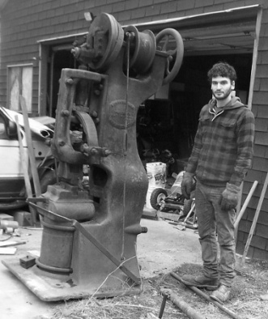

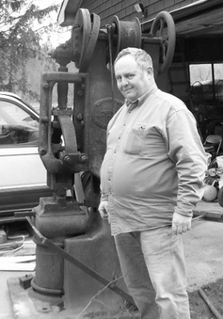

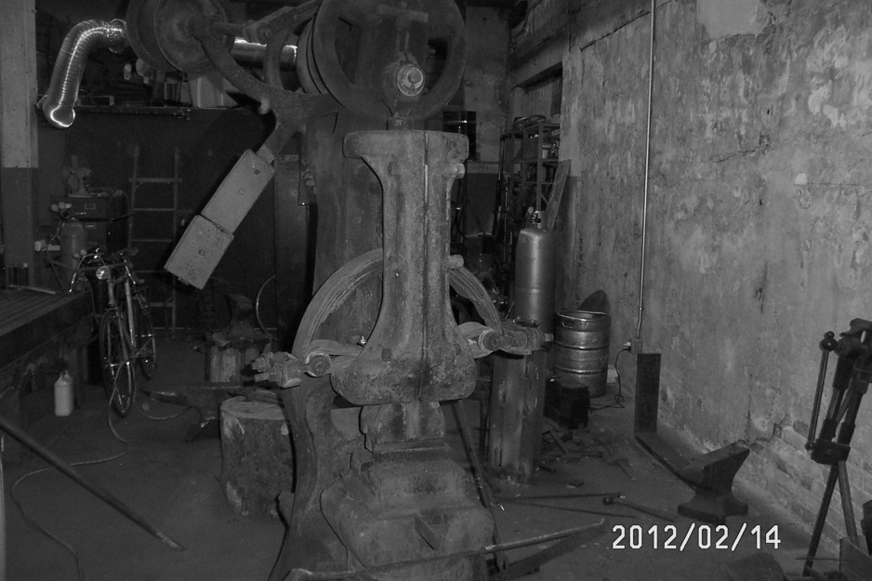

Jay Eibelheuser, who I affectionately call Jay “Jerky”, creates masterpieces in the culinary art of creating inventive types of jerky, from beef to bacon, from sweet potato to tofu, from alligator meat to tofu jerky. He also has a brilliant idea on marketing his products, using a branding iron to burn his logo into the top of various cigar boxes, which shall house his jerky samplers. He joined our group in order to fashion a special branding iron to use to place his logo onto the cigar boxes. Our group, under his guidance, is about to accommodate his wish, and create a product-based logo-installer for his novel products. And besides, all blacksmiths that I know love to eat!

TAILGATING
Any club members desiring to sell something should sent me a picture, description, price, and phone number via email to the below email address. The item(s) will be included in the next newsletter.
Sage Nippulini, a club member, has a friend of the family who is the owner/operator of an ornamental iron shop in the Northern Liberties section of Philadelphia. He is currently liquidating his entire shop. Equipment available in his shop includes a nice pedestal grinder, several drill presses, an abrasive cutoff saw for metal, a bunch of arc welders, a cold twisting machine, an ironworker, a lot of perishable tooling including welding rods, oxyacetylene rigs, and tons of steel on racks. Interested parties should contact me by phone, or talk to Sage at the next meeting, this Saturday. Here are some pictures and prices.
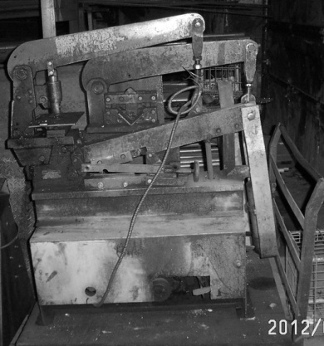 Ironworker
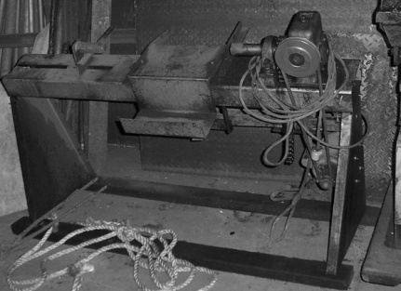 Cold Steel Twisting Machine $800.00
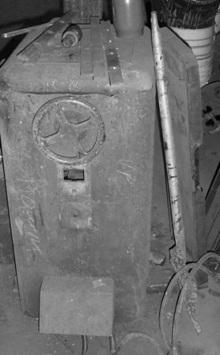 3 Phase Arc Welder(works!)$300.00
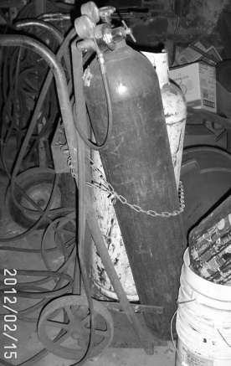 Oxyacetylene Rig, including torches and cart(but not bottles) $100.00
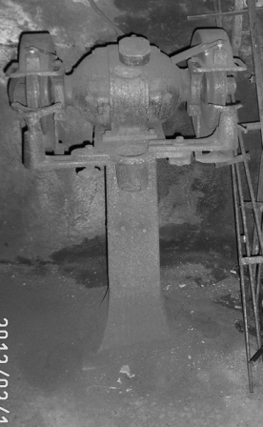 Real Nice Pedestal Grinder(large) $300.00
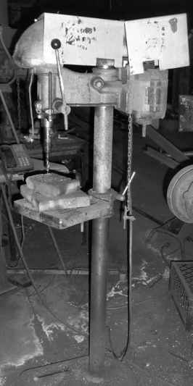 Nice Floor Model Drill Press $150.00
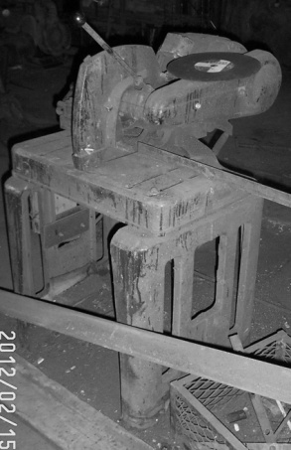 Sweet Metal Cutting Abrasive Cutoff Saw $400.00
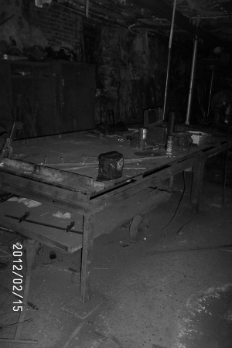 Giant Layout, Welding Table Make Offer
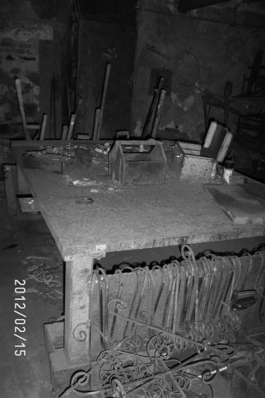 2nd Layout, Welding Table Make Offer
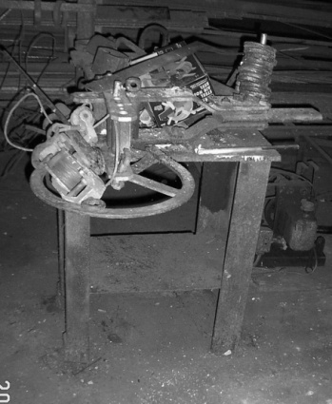 Hossfeld Bender $300.00
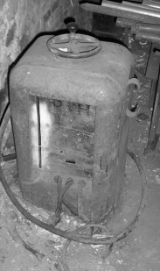 3 Phase Arc Welder #2 $300.00
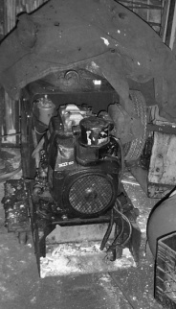 Miller Portable Diesel Welder $500.00
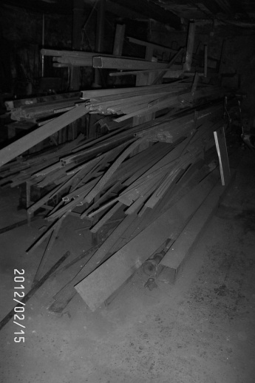 Tons of Steel on Racks Negotiable
Contact Information: Editor Stuart Geisler, 215-768-5735 stampmanstuart@juno.com

EXCELLENT BLACKSMITHING WEBSITES
- www.anvilfire.com
- www.forgemagic.com
- www.iforgeiron.com
- http://blacksmith.org/forums/forum.php
- https://sites.google.com/site/stuarttheblacksmith/home
On the last site mentioned, my website, I have devoted a page to our group!

