HAMMERTYME
NEWSLETTER OF THE PHILADELPHIA BLACKSMITH’S GUILD
VOLUME 1 ISSUE 3 February 2012

GOOD NEWS!
I am happy to say that our numbers are increasing. Our membership is up to 25 people and counting! Everyone attending our events is encouraged to bring friends, who might be interested in this craft. We are insuring the growth of blacksmithing in the Philadelphia Area! We want to recruit young and old, male and female, experienced and new to blacksmithing. See you at the meeting!
MISSION STATEMENT
As the birthplace of the United States of America, Philadelphia played a very important role in the development of this country. We have a rich tradition of blacksmithing in this city. During the 18th Century, Philadelphia was the second largest city in the British Empire. Everywhere you looked, there were blacksmith shops in this city. That proud tradition continued into the 20th Century, with some of the greatest blacksmiths in history setting up shops here, like Samuel Yellin, who employed hundreds of metalworking artisans in West Philadelphia, to the Keyser Brothers, to more recent times, where craftsmen like Christopher Ray hammered at their anvils. In honor of that tradition, we are forming this organization to continue the ironworking tradition set forth by our forefathers, to educate neophytes to this craft, to act as a gathering-place for people, young and old, experienced and those wanting to learn blacksmithing, and to demonstrate for the public a craft which is exciting, productive, and fun. The function of this newsletter, which will be forwarded on a regular basis, is to solidify the bonds between folks who love the excitement and creativity which forge and anvil induce.
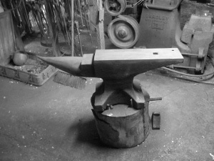
SCHEDULE OF EVENTS
Our next meeting will be on February 18, 2012, from 9:00 AM to 3:00 PM at Pennsbury Manor, just north of Philadelphia off of Bristol Pike(US Rte 13), and not far from I-95. We will all collaborate on a project for the Museum, forging several Lima Bean Latches out of railroad spikes. Members are encouraged to bring their own forges and anvils, because our demonstrations and lectures are “hands-on”. Members are also mandated to bring work shoes and safety glasses. To show our gratitude for providing a venue by all museums in our meeting lists, we shall be forging projects which the venues can be happy with! Don’t forget to bring a friend!
. Let the sparks fly, because it is HAMMERTYME!!!!!

OUR FIRST MEETING
Here are some pictures of our first meeting. A fun time was had by all! It was December 3, at the Ryerss Museum and Library in Burholme Park.
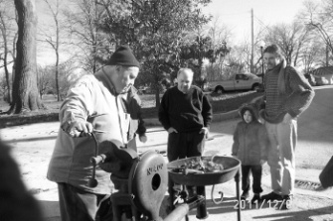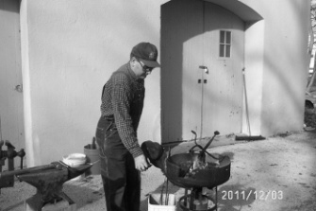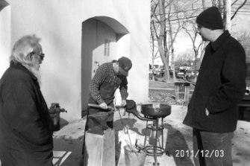
Stuart Geisler, Ben Suhaka, and Spectators Robert Herrmann at the Forge Dave Boyer, Bob Herrmann,
And John King
Our first event was very well attended, which bodes well for this craft. We had many spectators who signed up for our group! A good time was had by all!
OUR LAST MEETING
Our January meeting took place at the Holcomb-Jimison Farm Museum and Blacksmith Shop in Lambertville, NJ on NJ Route 29. Someone donated humongous blacksmith tongs, over five feet long, to the museum. The resident blacksmith there, Ben Suhaka, needed to forge chains in order to fasten those tongs to a vertical support pole in the blacksmith shop, so I gave a tutorial on forging chain links, using both bending forks and the anvil horn in order to shape the links for the chain. The I subsequently taught the entire gathering how to forge weld the chain links fast so that they hold. Everyone there did a very nice job, despite the frigid ambient conditions!
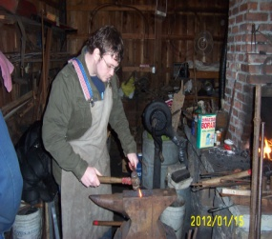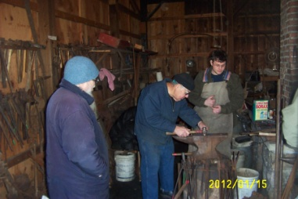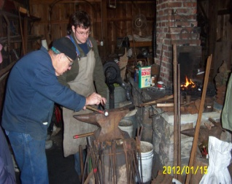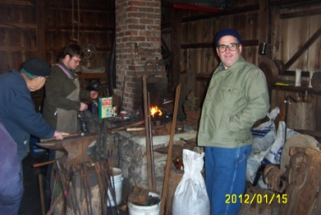
Pictured, left to right, are Jay “Jerky, Dave Boyer Ben Suhaka and Jay, Ben and Jay, and Ben Jay and Bob Herrmann
BEGINNERS CORNER

Everyone has to start somewhere. After acquiring the basic equipment for blacksmithing, anvil, forge, hammer, and blacksmith vise, the first thing a new smith needs to know is how to light a fire, which was covered in the Charter Issue of this newsletter. A very important skill in blacksmithing is bending hot metal. Last month’s beginner’s section covered the use of vise mounted bending forks for bending iron and steel. This month, I will describe how to forge weld a chain link.
BASICS OF FORGE WELDING
For thousands of years, before the invention of arc welders and acetylene torches, blacksmiths knew how to forge weld both iron and steel. To do this, two pieces of ferrous material need to be hammered together at an incandescent white heat. When you heat iron or steel that hot, to the point where the materials begin to spark, scale, or rapid oxidation, forms on the surfaces to be welded, which is a deterrent to forge welding. In order to remove these impurities, and get a sound, clean weld, a material called “flux” must be used. Flux comes from the Latin “to flow”, and that is exactly what flux does, it forms a liquid which attaches itself to scale and other impurities in the fire. When your iron gets bright orange hot, the surfaces to be welded need to be sprinkled with flux, either sand for wrought iron, or borax for steel, and then put back in the fire. Heating the pieces slowly to be welded, so that the heat penetrates evenly through the bar of steel or iron, the blacksmith waits until the pieces to be welded(previously fluxed) get white hot(signified by the pieces of steel beginning to spark), and then withdraws them from the fire, hammering the pieces to be welded very hard to drive out the flux and impurities and make sure the weld fastens the two elements together. Impediments to forge welding are pulling the pieces from the fire before they get hot enough, not hitting them hard enough to secure a sound weld, having a dirty fire, and lack of coordination. The key to getting good forge welds is practice! I am happy to say that everyone who tried to forge a chain link at the last meeting did an excellent job forge welding the links together once they got the knack! Remember, to get good at this, you need to practice!!!

MEMBER NEWS
One of our newest members, Dan Manders of Philadelphia, just acquired a very nice triphammer, a Scranton 70 pounder that he and I are rebuilding. The job is coming along very well, and this is an excellent hammer he purchased. Below, I am posting pictures of his new “toy”, in various stages of restoration. Dan has a beautiful shop, and has kindly offered his facility as a future meeting place for our group! Dan’s shop is alongside a wooden boatbuilding shop, where they hand craft wooden sailing vessels!
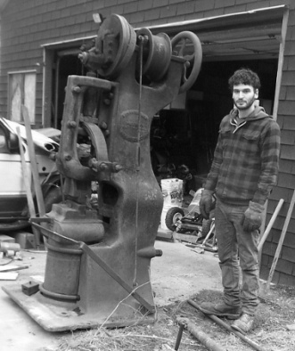

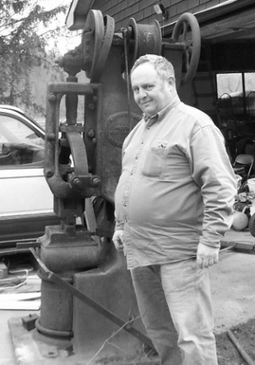

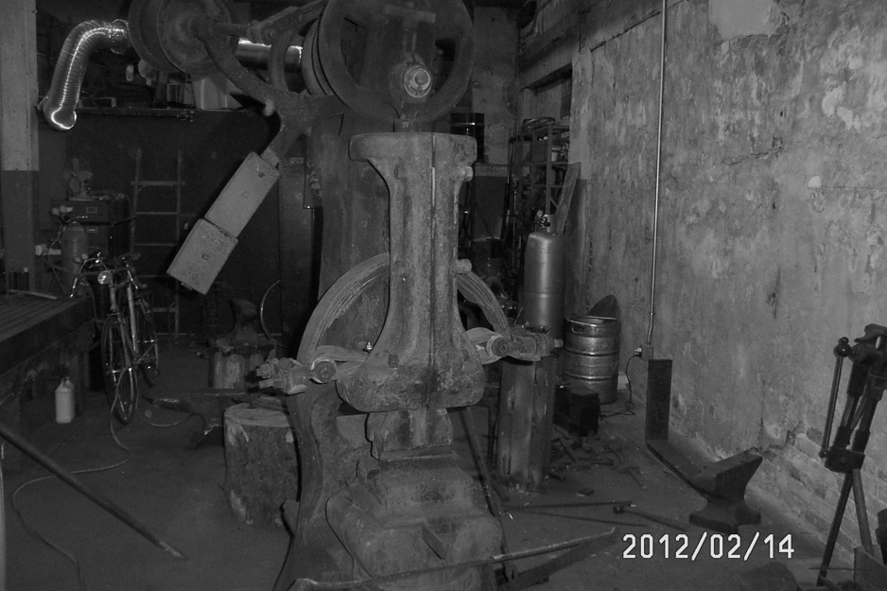

FYI, at our meeting this Saturday, the blacksmith at Pennsbury Manor, Bob Herrmann, is requesting that attendees participate in his Can Drive for charity, and bring canned goods to donate to his charity. These contributions will be greatly appreciated. It has been my experience that blacksmiths in general are very, very generous people!

TAILGATING
Any club members desiring to sell something should sent me a picture, description, price, and phone number via email to the below email address. The item(s) will be included in the next newsletter.
Sage Nippulini, a club member, has a friend of the family who is the owner/operator of an ornamental iron shop in the Northern Liberties section of Philadelphia. He is currently liquidating his entire shop. Equipment available in his shop includes a nice pedestal grinder, several drill presses, an abrasive cutoff saw for metal, a bunch of arc welders, a cold twisting machine, an ironworker, a lot of perishable tooling including welding rods, oxyacetylene rigs, and tons of steel on racks. Interested parties should contact me by phone, or talk to Sage at the next meeting, this Saturday. Here are some pictures and prices.
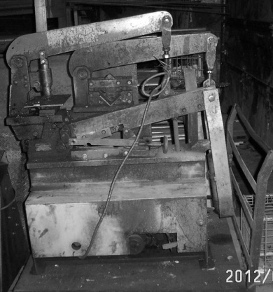 Ironworker
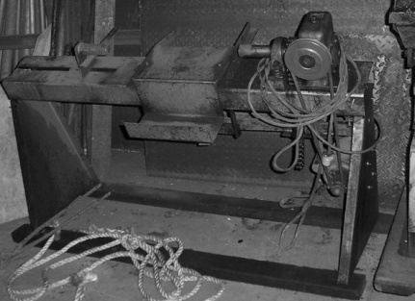 Cold Steel Twisting Machine $800.00
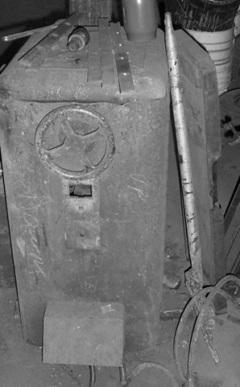 3 Phase Arc Welder(works!)$300.00
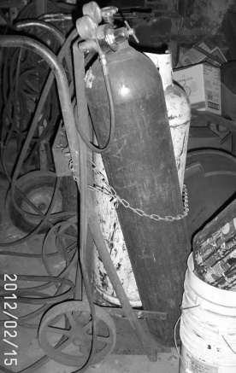 Oxyacetylene Rig, including torches and cart(but not bottles) $100.00
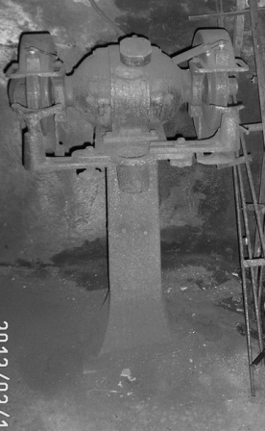 Real Nice Pedestal Grinder(large) $300.00
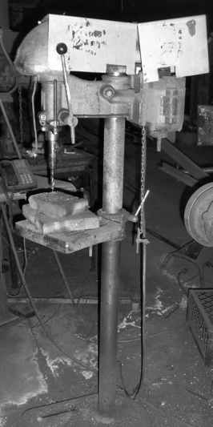 Nice Floor Model Drill Press $150.00
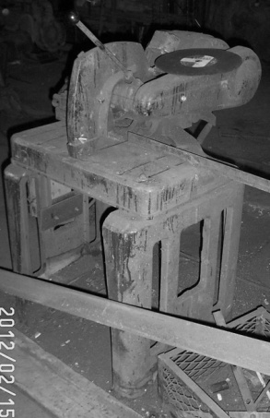 Sweet Metal Cutting Abrasive Cutoff Saw $400.00
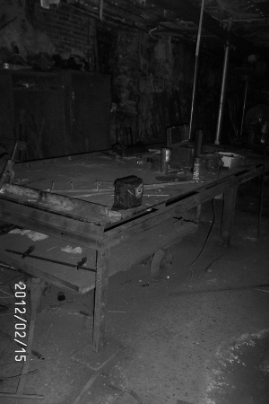 Giant Layout, Welding Table Make Offer
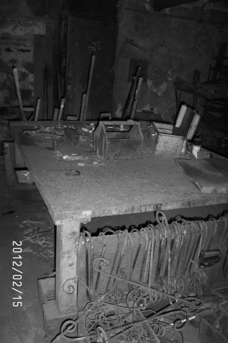 2nd Layout, Welding Table Make Offer
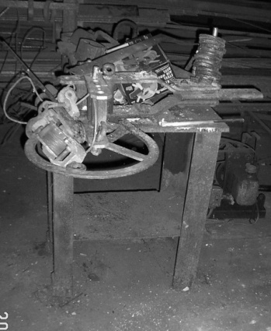 Hossfeld Bender $300.00
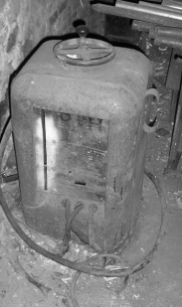 3 Phase Arc Welder #2 $300.00
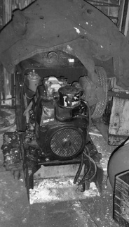 Miller Portable Diesel Welder $500.00
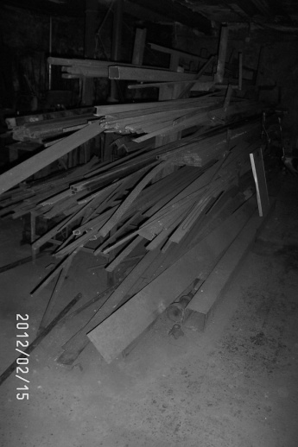 Tons of Steel on Racks Negotiable
Contact Information: Editor Stuart Geisler, 215-768-5735 stampmanstuart@juno.com

